Exercise 4: Creating and Configuring a Maven Project
Scenario:
You need to set up a new Maven project for the library management application and add Spring dependencies.
Implementation:
Pom.xml
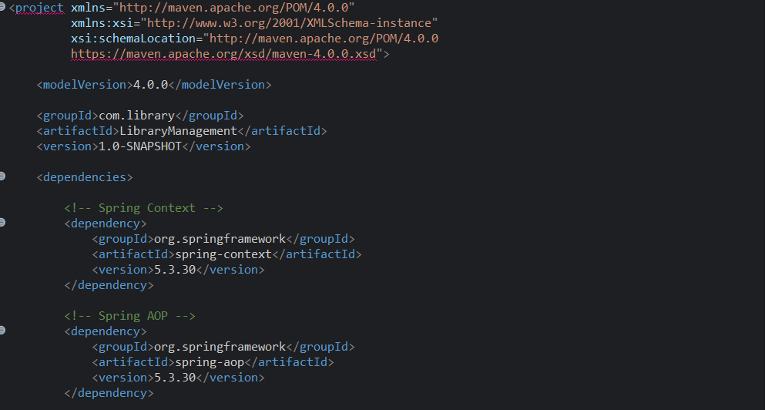
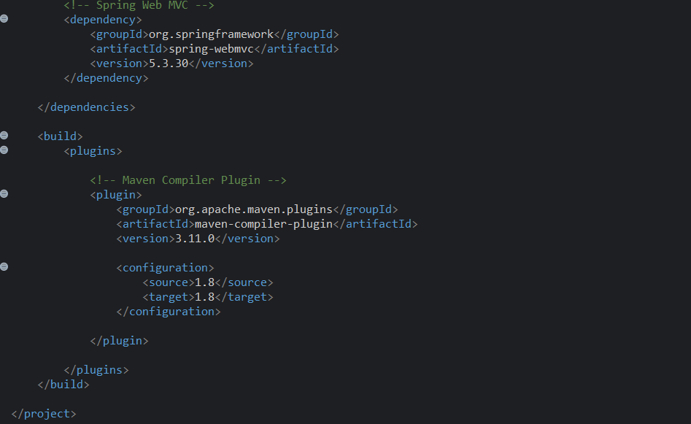
Explanation:
- spring-context: Provides the Spring IoC container and dependency injection features.
- spring-aop: Provides Aspect-Oriented Programming support.
- spring-webmvc: Provides Spring MVC framework for web applications.
- maven-compiler-plugin: Configures the project to compile using Java 1.8.

